80-HOUR PTO Train-the-Trainer CLASS
OPTIONAL: Sign up for only the 40-hour Basic Course
October 9 – 20, 2017 Las Vegas, Nevada
Offered by:
The Hoover Group of Reno
hoovergroupofreno@sbcglobal.net
775-233-1657
The 80-hour Train-the-Trainer Course prepares the trainer to teach the 40-hour Basic PTO Course as well as how to develop and implement the PTO Program. All topics taught in the Basic Course will be covered as well as advanced topics and opportunities to create audio-visual presentations of the material. The participant will be exposed to leadership and adult-learning principles in greater depth.
All participants will research, prepare, and present topics relating to the Reno Model. An instructor’s manual and PowerPoint presentation are provided.
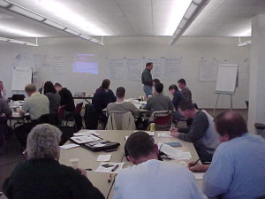
The fundamentals of post-academy training are covered including problem-based learning theory and method, available training resources, evaluation methods, emotional intelligence, the Learning Matrix, cooperative learning, mentoring, and the Neighborhood Portfolio.

PTO Program Key Benefits:
- Trainees become problem-solvers and community-oriented police officers.
- The training experience is positive, the trainee and PTO work as a team.
- The agency benefits from a federally approved training model.
Cost:
The 80-hour Train-the-Trainer PTO Course cost is $1000 per person. If an agency sends two people, a third person may attend for free.
40-Hour basic pto course:
The 40-hour Basic PTO Course prepares the trainer to become a Police Training Officer (PTO) under the Reno Model.
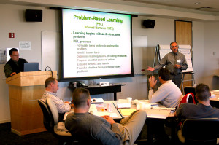
The fundamentals of post-academy training are covered including problem-based learning theory and method, available training resources, evaluation methods, emotional intelligence, the Learning Matrix, cooperative learning, mentoring, and the Neighborhood Portfolio.
Cost:
The 40-hour Basic PTO Course cost is $500 per person. If an agency sends two people, a third person may attend for free.
Instructors:
Jerry Hoover
Chief Hoover retired as the Reno (NV) Chief of Police. He has trained officers in the U.S., Sudan, Iraq, Afghanistan, New Zealand, and Botswana. He led the group that designed and implemented the PTO Program for the COPS Office, DOJ.
David Ponte
Mr. Ponte retired from the Reno (NV) Police Department where he was the field training coordinator for both FTO and PTO models. Dave has been with the PTO program from the very beginning.
Clair Walker
Mr. Walker retired as a sergeant with the Boise (ID) Police Department where he was the field training coordinator for both FTO and PTO models. Clair has been teaching with the Hoover Group for nearly 15 years.
Register for the class:
You may register for the class by e-mail (jerryhoover@sbcglobal.net). Payment must be mailed before September 9, 2017. Mail to:
Jerry Hoover
8010 Silver King Dr.
Las Vegas, NV 89129
Class Location:
Santa Fe Station Hotel Casino in Northwest Las Vegas. This is a full-service hotel approximately 15 miles from the airport, 11 miles from the Strip, and 10 miles from the downtown Fremont Street Experience. The hotel has several restaurants as well as theaters on site.
Room rates:
Sun-Thur - $54 + $13 service fee + taxes = $75 per night (approx.)
Fri/Sat - $75 + fee/tax + $95 per night (approx.)
Address: 4949 N Rancho Dr, Las Vegas, NV 89130

Please make reservation at: (866) 767-7771 and identify yourself as an attendee of the “Hoover Group” or ask for offer code ACIHOOV. You may also click on https://santafestation.sclv.com/hotel and enter code ACIHOOV when prompted.

